**Logical Model**

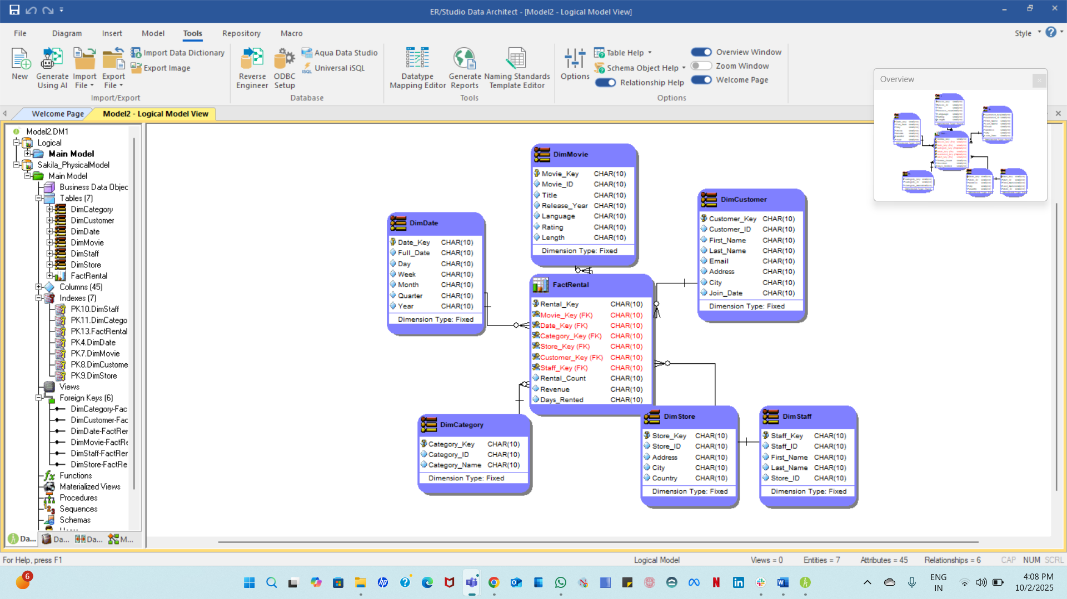

**Physical Model**

**Changing Datatypes**

The constructed **Star Schema** efficiently meets the analytical and reporting requirements of the organization based on the **Sakila Movie Rental** business operations. It provides insights like monitoring **customer onboarding trends**, comparing **revenue at the store** level across various time frames, pinpointing **high-performing customers and staff**, and examining the **frequency of movie rentals**.

All these business needs can be fulfilled by executing **aggregations and joins** on the central **Fact_Rental** table along with the relevant **dimension tables** (Date, Customer, Movie, Staff, Store, and Category). This dimensional approach guarantees enhanced query performance, streamlined analysis, and flexibility for upcoming analytical requirements.

* **Customer Onboarding:** Derived from Dim_Customer joined with Dim_Date (using customer creation date) to track new customers by day, week, month, or year.
* **Most Rented Movie:** Fact_Rental joined with Dim_Movie and Dim_Date to find the most frequently rented movie per day.
* **Store Revenue (Daily)**: Fact_Rental (or Fact_Payment) joined with Dim_Store and Dim_Date to calculate daily revenue per store.
* **Revenue Comparison (Monthly):** Same fact joined with Dim_Store and Dim_Date to compare monthly revenue trends.
* **Monthly Rentals vs Last Month:** Fact_Rental joined with Dim_Store and Dim_Date to compare month-over-month rental counts.
* **Top Customers:** Fact_Rental joined with Dim_Customer and Dim_Store to identify top 5 customers by rental frequency or total spending.
* **Top Employees:** Fact_Rental joined with Dim_Staff and Dim_Store to identify top 3 staff members assisting customers.

The **grain** of the fact table defines the level of detail captured for each record.  
In this model, each record in the **Fact_Rental** table represents one rental transaction at a specific store, for a specific customer, and on a specific date.  
This means the grain is:

**“One record per movie rental transaction (per customer, per store, per date).”**

This level of granularity ensures that all business requirements — such as comparing rentals over time, identifying popular movies, and calculating revenues — can be answered using summarized aggregations.

**In Account Admin**

**In Media Role**

